Human Swarm Intelligence

By Author: 'The Rationalist Society'

Human Swarm Intelligence: The Most Powerful Tool For Humanity You Likely Never Heard Of
  - A different kind of AI that captures the wisdom of the crowd.
THE RATIONALIST SOCIETY
AUG 20, 2023
46

40

14

Share

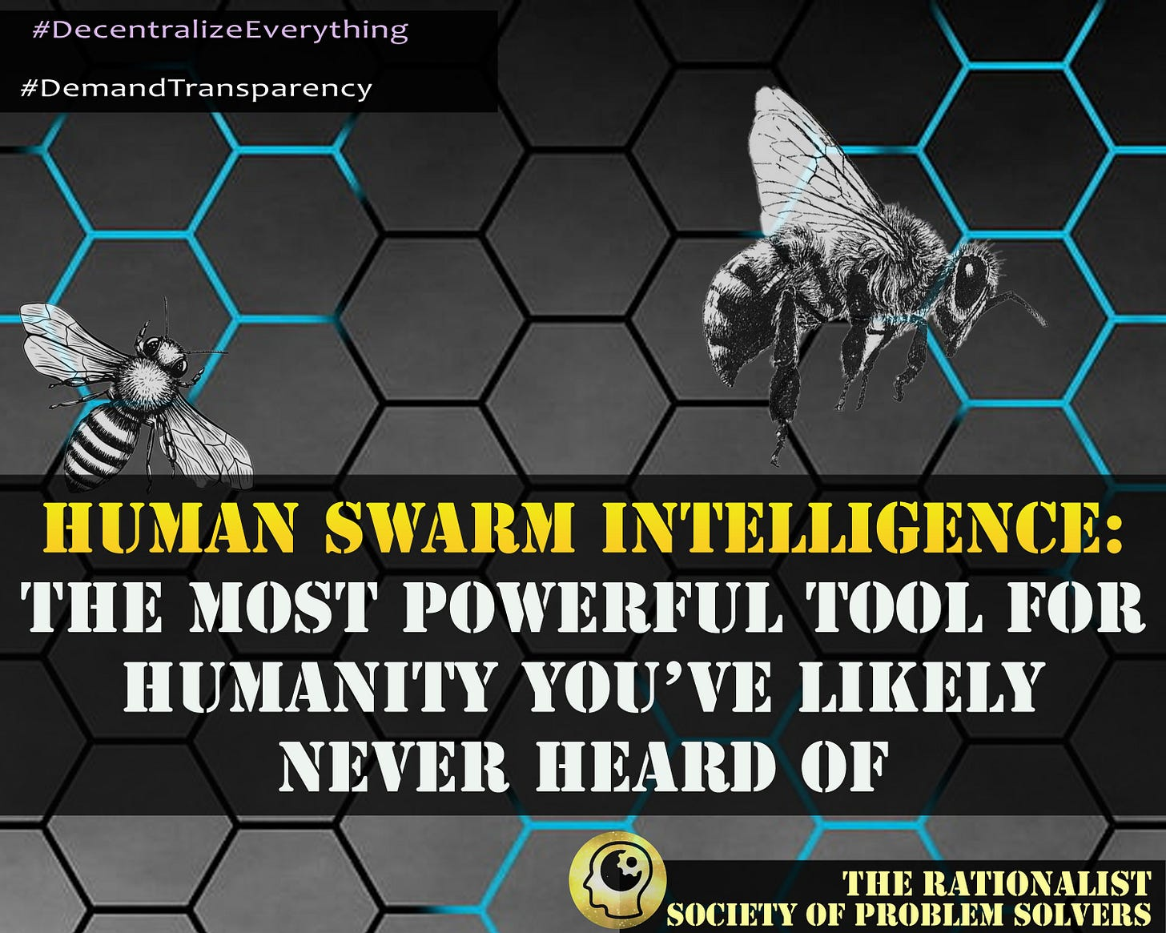

When we talk about “hive minds” or “swarms” people often start off with the wrong idea. They picture a queen-like leader in control of the masses, commanding the drones exactly how to behave. Or even worse, they picture groupthink, where everyone making the decisions is in prior cohesion with each other. But Human Swarm Intelligence (swarming) is actually the opposite of these types of systems. In fact - if done correctly - swarming strongly prohibits any group that is solving problems together from sliding into groupthink, and by design, it automatically operates as a leaderless system and therefore has no centralized “queen” in control. It is a decentralized bottom-up system, rather than a centralized top-down one.
One way to look at it is this:
- If cohesiveness comes first, then the danger of groupthink is high.
- If cohesiveness is the output of individuals with varying opinions, then the danger of groupthink is almost nonexistent.
In other words, Human Swarm Intelligence thrives on disagreements within the group. It can take groups of people who are far apart on their positions, to find agreed upon answers.
If this is true, imagine the implications for our world today. Right now we are a highly divided world: the polarization is palpable. If we keep on the path we are on now, how long will we continue to allow these hot button topics to divide us? 50 years? 100 years? For eternity? Imagine if we had a tool where we could take groups of highly divided people and come up with answers to some of our most challenging and difficult problems, and get past them. That’s just a fraction of the power and potential that Human Swarm Intelligence can harness.
Since we were first introduced to Human Swarm Intelligence, we have been fascinated by the possibilities. After reading the book ‘The Starfish and The Spider: The Unstoppable Power of Leaderless Organizations and understanding the ‘Last Hand on The Bat’ theory of decentralized systems (like we wrote about here), the positive outcomes of a tool like Human Swarm Intelligence seem almost limitless to us. We can picture everything from governments to businesses to unions and more being able to be run in a decentralized fashion.
To help us understand Human Swarm Intelligence further, we were able to interview two people who have dedicated their lives to unlocking the potentials within it.

Founder Dr. Louis Rosenberg
The first person is someone who most consider the father of Human Swarm Intelligence (although he prefers to call it simply “Swarm AI”), Dr. Louis Rosenberg. Dr. Rosenberg is a lifelong technologist in the fields of human-computer interaction, artificial intelligence, and mixed reality, and the founder and CEO of Unanimous AI.
When most of us think of “Artificial Intelligence” we think of replacing human intelligence with algorithms. Dr Rosenberg has a different view, “Unanimous AI (is) a very different type of artificial intelligence company. Our mission is to use AI to amplify human intelligence, enabling networked human groups to form superintelligent systems.”
Collective Intelligence (sometimes simply referred to as “the wisdom of crowds”) is the overarching field of research where Dr. Rosenberg’s systems reside.
He explains, “The methods have changed very little over the last 100 years (for Collective Intelligence). The standard approach is to collect data from a group of people through a poll or survey, run statistics on the data, and produce an aggregated result.”
Dr. Rosenberg continues, “About 10 years ago, I founded Unanimous AI asking a basic question – is there a fundamentally better way to amplify the intelligence of groups. And like many researchers, I looked to Mother Nature for guidance and inspiration. It turns out, evolution has been wrestling with this issue for hundreds of millions of years and has enabled many different organisms to amplify their group intelligence in far more effective and efficient ways.”
Swarms of bees, schools of fish, flocks of birds, ants, and many more species make real-time decisions as groups in nature. He continues, “Biologists call the method ‘Swarm Intelligence’ and they make significantly smarter decisions together than alone. They do this by forming real time systems in which all members push and pull on the direction of the decision, like a giant multi-directional tug-o-war, until the group converges on the one decision they can best agree upon. And it turns out it’s usually the optimal decision.”
He adds, “So, for the last 9 years our researchers at Unanimous AI have been developing methods that enable networked human groups to form real-time systems modeled on biological swarms. And it works, enabling groups of all sizes (5 people to 250 people or more) to all work together in real-time, pushing and pulling on each other as an AI-mediated system that quickly converges on optimized decisions that combine their knowledge, wisdom, insights, and intuition. It turns out it works better than we expected, enabling significantly more accurate forecasts, decisions, prioritizations, and assessments.”
Back in 2017 Dr. Rosenberg gave an enlightening Ted Talk that really showed the intricacies of this technology. At the pinnacle of the video, he uses his version of Swarm AI to take a group of horse racing enthusiasts - none of whom were able to correctly predict it on their own - to swarm and correctly predict the superfecta of the Kentucky Derby - the top 4 horses in a row. There was a Newsweek reporter that followed them through the process.
It was through this Ted Talk that we were first introduced to Swarm AI and the possibilities it unlocks.
Outside of the Kentucky Derby, Dr. Rosenberg has been able to prove Swarm AI’s real world use in many other fields. Commercial sales forecasting, sports betting (they have a direct spinoff called “Sportspicker AI” that has consistently beat the Vegas oddsmakers many years in a row now (read more HERE), marketing, and even being able to predict the locations of famines and thus get ahead of the aid needed for them are just a few examples. Medicine and finance are two other fields where swarming has proven itself. Dr. Rosenberg elaborates, “We worked with researchers at Stanford Medical School to test the value of Swarm among small groups of doctors and found that they could reduce their diagnostic errors by over 30%. We worked with researchers at MIT to test Swarm with financial traders and found they could amplify the accuracy of market forecasts by over 25%.” (Read more about these studies here).
“The use of (traditional) AI to replace human decisions has exploded, impacting everything from hiring decisions and loan decisions to sentencing decisions in court cases,” Dr. Rosenberg explains. “Even military decisions are being automated by AI, humans taken out of the loop. I believe this is a terrifying direction because AI-powered decisions do not accurately reflect human values, morals, insights, or sensibilities. We need to keep humans in the loop.”

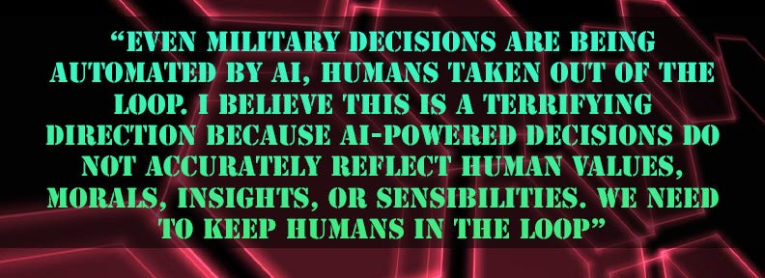

Rosenberg Continues
He adds, “With Swarm (Human) AI technology, we get the benefits of AI by connecting humans together, not replacing them with algorithms. And it works really well, allowing smarter decisions, more accurate forecasts, and more efficient prioritizations. We’ve already been testing the technology with the U.S. Air Force for decision-making applications that keep humans in the loop. We are also working to get government agencies to use Swarm AI as a path to finding solutions that conflicting groups can best agree upon. That’s what swarms are good at.”
If you have read any of our previous articles here at The Rationalist Society of Problem Solvers you can probably extract the excitement we would have for using Human Swarm Intelligence in governmental systems, both for fighting against the corruption that is currently destroying our systems, but also for running all governments in a more decentralized manner. Dr. Rosenberg shared some of his excitement about the possibilities of government and saw it as a way to replace polling. He thought that grassroots groups that wanted to fix society would be an ideal use of the technology.
However, there seem to be several big barriers to being able to use swarming for massive undertakings such as self-governance. The first is that swarming usually requires a fixed set of inputs. For example, the Kentucky Derby has a finite set of horses to choose from that were already predefined. Along these same lines, another barrier is scalability for both swarming and generating these inputs.
Dr. Rosenberg mentioned a new technology that Unanimous AI is working on called ThinkScape™ that sounded intriguing. ThinkScape enables human groups to form real-time swarms through conversation deliberations that surface some of the inputs using natural dialogue. “We call this approach ‘Conversational Swarm Intelligence’ and early testing at Carnegie Mellon University shows it works even better than we hoped,” he added.
Another problem that prevents swarming from being scalable en masse is the simple fact that it is often hard to get thousands of people to participate at the exact same time. To solve this, Unanimous AI has a new technology called MindMix™ that is coming out later this year that enables groups to form real-time swarms even if not everyone is present at the exact same time (demo here). There is an academic paper coming out in November that tests this method with human groups to show its accuracy.
Yet another hindering barrier for Swarm AI to be adopted by the masses is cost. Unamimous AI uses subscription fees in order to access their systems. They are reasonable if you are a business or larger organization looking to maximize your decision making, but may not be as practical or available yet for the average everyday user.

Founder Setz
We spoke with a different founder and developer who asked that we use his online name, “Setz,” since that is what he is well known by in the programming and gaming communities. Setz has been working with his team on a different kind of Human Swarm Intelligence system for the past 5 years that they call Voy. With Voy they are attempting to tackle this problem of affordability along with several of the other scaling issues that Unanimous AI is currently working on.
“Voy is short for the voyage - we are all together atop this little rock hurtling through space - and it combines gamified human swarm intelligence with user generated communities within the context of a wisdom marketplace.” Setz told us in an interview. “If that all sounds like buzzwords to you, I can say it this way: It’s a game that pays you to play it and the objective is to join up with others in real time to create a really smart ‘brain of brains’ to answer any question and ultimately make income. Or you could think of it as ‘the gig economy of wisdom, owned by everyone.’”
Setz is a career designer with 20 years of experience in graphic/web design, user experience design, and game design. Additionally, he built a subreddit with over 3.5 million subscribers. He is an activist as well, spending years of his life designing software for social good. He sees Human Swarm Intelligence as a way to outmode the broken and corrupt systems that govern over our lives today.
In our conversation, Setz’s deep appreciation for Swarming was apparent from the start. He started by citing the work of Francis Galton in the early 1900s, where the term “Wisdom of the Crowds” was coined. He quoted National Geographic as saying, “In 1907, Sir Francis Galton asked 787 villagers to guess the weight of an ox. None of them got the right answer, but when Galton averaged their guesses, he arrived at a near-perfect estimate. This is a classic demonstration of the ‘wisdom of the crowds’, where groups of people pool their abilities to show collective intelligence.”

Setz continued
Setz continued, “The ‘Wisdom of Crowds’ effect has happened many times throughout human history, but only since the computer age have we begun figuring out how to manifest and use it to our advantage. Search engines are considered an example of the wisdom of crowds—large amounts of wisdom collected from humans are ranked and made searchable for the benefit of everyone. Search Engines have resulted in, of course, an information explosion comparable to other internet fundamentals like the web browser or email.”
He added, “The real breakthrough in Human Swarm Intelligence has gone almost entirely ignored by humanity (to my continued shock). Considering how profound this breakthrough was, I’m left to simply conclude that most people either don’t understand the breakthrough itself or can’t comprehend its significance.”
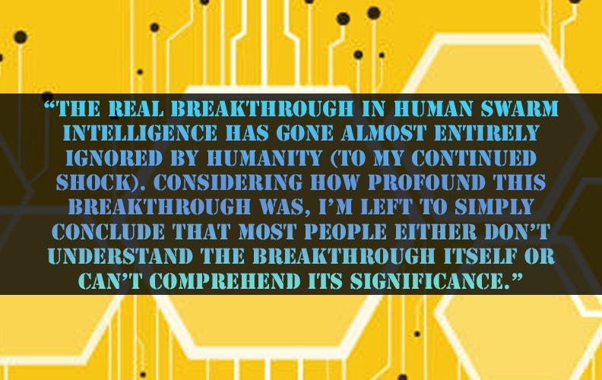
Setz also spoke very highly of Dr. Rosenberg and the things Unanimous AI has done in the field of Collective Intelligence. In fact, he also attributed Dr. Rosenberg’s work as the reason he became interested in Human Swarm Intelligence, also calling him the “Father of Human Swarm Intelligence.”
But Setz has visions that seem to differ from those of Dr. Rosenberg as well. With more of a gaming mindset from his decades of experience in game design, he sees his system, Voy, as a way to achieve goals on a massively grand scale. By gamifying Swarming and making it free and accessible to all, like a social media platform, his objectives are greatly expanded. He explains, “I consider Voy a ‘Universal Employment’ solution in that it is designed from the ground up to benefit every single human who joins it, regardless of intelligence, ability, experience, location, etc. This can be done by leveraging human swarm intelligence so that the contributing minds of each participant are creating something greater than they could as individuals. The wonderful side benefit here is that each participant is learning while they participate, so the collective also gets smarter every day.”
Setz’s visions for Voy are so grand, in fact, that when we first met him, one of the ice-breaking questions he asked right off the bat was, “Are you interested in ending poverty?”
Since we first met Setz last year, he has given us several presentations on how Voy works. One of the things we noticed first was how it solved the scalability problem that seemed to exist with baseline Human Swarm Intelligence. How could massive groups of people come up with a meaningful consensus over time? By using what he calls “hives.” Voy’s user generated communities mean organic swarm intelligence with the right levels of access, creating useful responses at scale.
Unlike swarming applications with fixed inputs—such as what was done with the Kentucky Derby,—Voy allows each user to come up with their own creative answers for problems. This process could be thought of as “Human Swarm Imagination” - a way to gather meaningful inputs from each individual user. Then those inputs are used by Swarms to find the best responses.
”To my surprise, this discovery has gone largely unnoticed by the world at large, with no one utilizing this phenomenon to benefit humanity (as a whole).” Setz told us. “In the fall of 2018, I began to deeply ponder this question: ‘What’s the greatest possible good I can do?’ All I could think about was how if everyday people just had more money to work with, everything would get better. Mental and physical health, happiness, and everyone’s ability to take care of the people they love. One thought led to another until I remembered Rosenberg’s HSI work—in fact, I had tried it myself when it was in an open beta (It is now a private piece of software he uses for business consulting). I realized that if humanity had a networked superintelligence, it could earn income that could be distributed to every participant regardless of their ability, intelligence, location, etc. This thought excited me so much that I wrote a whitepaper (link HERE) called, ‘The Human Hivenet.’ But after completing the whitepaper, I realized that it was such a niche idea that I might never find another person who could understand it, let alone build it.”
Setz began to deeply consider his options. In the prior decade, he had gotten a lot of experience creating and growing communities on Reddit, including ones with millions of users. That’s when another realization hit him: The Human Hivenet would need user generated communities like subreddits so that groups would be organized according to bias.

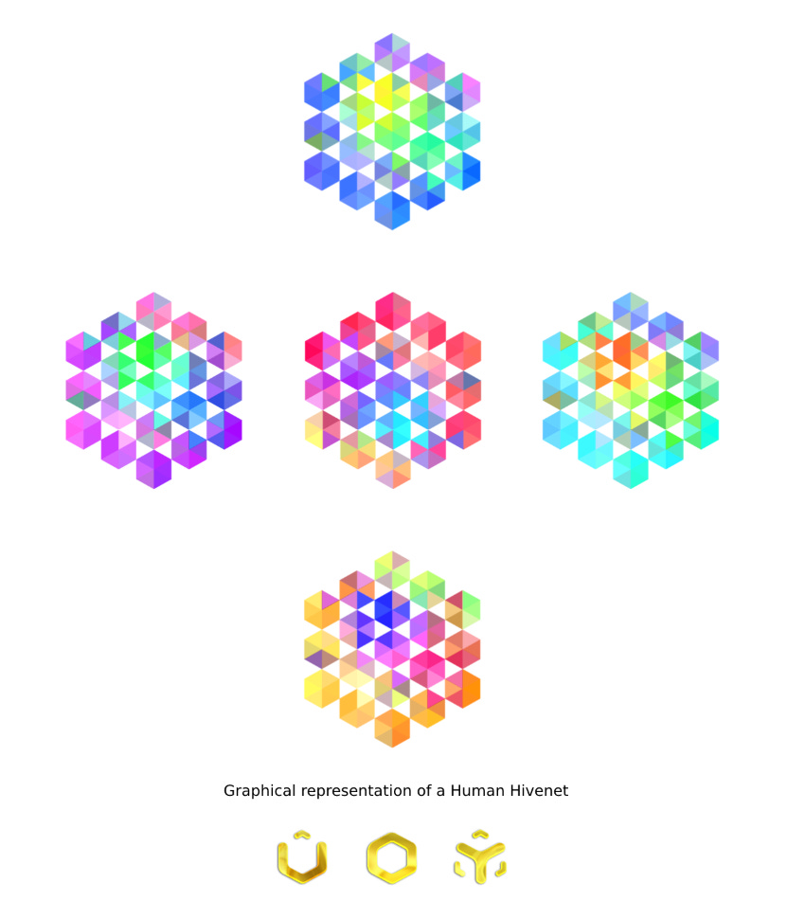

Setz continued, “In 2019, I ran a few proof-of-concept iterations to validate my ideas on how swarms could be run differently than how Rosenberg had done it. To my excitement, they worked! And even in a more scalable way than he had devised, because my approach integrated freeform answers into the swarm thinking. I built an intricate prototype using Figma that covered all of my ideas and worked on further refining them. As I neared the end of 2019, I grew frustrated that I couldn’t afford the high cost it would require to hire a developer to build my vision.”
Then Covid hit. Like many of us, Setz suddenly found himself with a lot of time on his hands.
”I took this as an opportunity to build my vision,” Setz continued. “I hired a fiverr developer to create a Discord bot that would generate my form of HSI by talking to a group of people simultaneously and running their responses through my algorithm to generate a single smart answer. It was buggy and broken, but in the most basic sense, it worked!”
As 2020 progressed, he built a team of people to work on the project with him, and they tested numerous features and iterations until they ran up against a brick wall: Discord simply couldn’t handle how many data calls needed to run such a complex system. So they turned to another platform called Flutter and began to build a cross-platform web app.
“Over 2021 and 2022, we built and iterated until we had a beta that I was calling Early Access. The software delivered on what I had intended—we could gather a group of people together in real time to participate in a human swarm intelligence game and generate answers that were smarter than the individuals in the group. The responses were concise and often witty—and I knew we had something when swarms started to respond more intelligently than I could.”
Here is an example of one of the questions answered with Voy using a small swarm during early access:

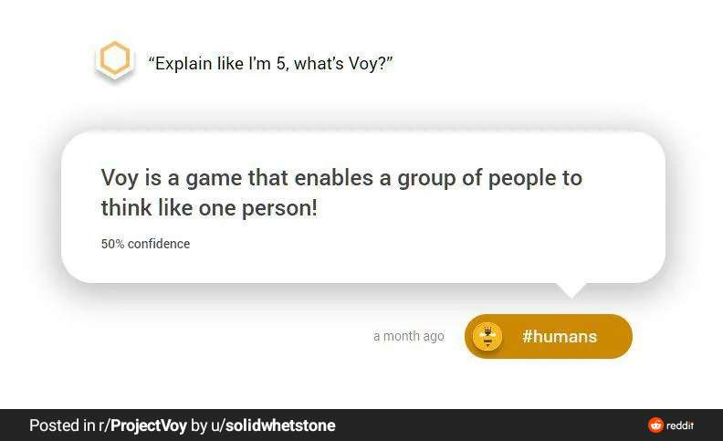

As 2023 arrived, the small team at Voy scoped out the next piece of development: A reimagining of the user experience and delivering on the promise of stable, scalable human swarm intelligence available for all.
“Voy uses a fundamentally different approach to HSI that factors in freeform responses within the context of user generated communities,” Setz disclosed. “It is also designed to support monetary systems for user generated communities so that participants can get paid to participate and play. And, importantly, Voy is intended to eventually be an open source system that can be installed and configured by anyone to connect to a larger networked intelligence, free of charge.”
He punctuated, “I believe that Human Swarm Intelligence should be in the hands of everyone.”
At The Rationalist, we could immediately see the benefits of how a tool like this could be implemented in all self-governing or decentralized systems. From democracies to DAOs… something like this could be a massive game changer. Especially if it was accessible to all.
Setz continues, “Voy actually works around governments in the same way that DAOs (Decentralized Autonomous Organizations) do—it would allow communities to take collective action without needing to pass laws or deal with red tape. The system is organic, so new communities can form and new channels of money can spring up to take on emerging problems. When it comes to swarms vs. voting, swarms are faster, more intelligent, and better able to factor in the will of individual participants.”
We then asked Setz if he thought Voy could be used to end the corruption in our systems of government. He responded, “It may be that our current system is beyond saving and cannot be redeemed. This has to do with bad actors with great sums of money being able to control legislation. For this reason, I think new systems need to arise that can work around these corrupt governments and ultimately outpace them through
- faster action and
- greater citizen enthusiasm.
To me, it seems like it would take a monumental amount of work and money to attempt to retool the broken governments we have today, and a lot less work and money to build new and better systems that operate more efficiently while aligning better with human interests. So when it comes to the question of, ‘What can I do?’ I think building better tools that can outmode today’s corrupt government is the way to move forward without creating power vacuums that could invite even worse actors to arrive.”
He continues, “We have seen the success of decentralized systems like cryptocurrency and P2P—we can see how these systems cannot be easily taken down by governments and provide alternate means with which to fund projects and raise capital. So there’s already some good case studies showing that decentralization works. We just need a large enough decentralized system.”
Admittedly, Voy isn’t well enough funded yet to reach all of its goals, and after years of grassroots programming it has just begun actively seeking and adding investors. “Enough people have to believe in it to get us there, and to believe in it, they have to first understand it. Getting people to understand it has been the hardest challenge because it’s such a foreign concept to how we think.” Setz explains. “It’s like they’re hearing another language. But considering how little we’ve had to work with up to this point and the amazing progress we made getting all the way up to beta, I believe we are not far from realizing this project’s potential once the right people get interested.”
Once you see and understand the power of Swarming, and “organized decentralization” it is impossible to unsee.

Author, 'The Rationalist Society'
We want to thank both the team at Unanimous AI and the team at Voy for sharing and developing what we believe is the future of humanity. Human Swarm Intelligence is one of the most promising fields for solutions that we see exists, especially when it comes to fixing our biggest problem - the corrupt systems that govern our lives. We believe it is a major part of the path needed to take our civilization to the next level. Like Setz, we are shocked that more people have not expressed interest in studying, developing, and investing in this field of Collective Intelligence with more gumption.
It is our goal to one day get a candidate into office and use Swarming as a way to make every decision with the constituents, by using the process where elected leaders decentralize their own leadership (like we wrote about HERE). Let’s face it, we can’t fix the broken system using the current methods within the system itself. Instead we need to build new systems and plug them into the existing corrupted system and change everything- without permission or any help from the government itself. To us, the field of swarming is the most exciting possibility for humanity that currently exists.
At the end of every article since day one—for almost two years now—we have signed off like this:
For over 3 billion years on this planet there were only single-celled organisms. Then one day they somehow learned to work together and make complex multi-celled creatures . Right now we are like those single-celled organisms. Our next evolution is finding how to work together, better…
Doesn’t it sound like swarming in an answer to this evolution?
We are considering starting one of Balaji Srinivasan’s Network States, and using it as a hub for everyone interested in Human Swarm Intelligence or Collective Intelligence. Until then, we plan on continuing to support all those working on ways to get there, and look forward to seeing how Unanimous AI and Voy continue to evolve!
Contact Dr. Rosenberg and the team at Unanimous AI:
email: Louis@Unanimous.ai
website: https://unanimous.ai/

Contact Setz and the team at Project Voy:
https://www.projectvoy.com/contact

Thanks for reading!
Thanks for reading The Rationalist - Society of Problem Solvers! Subscribe ALWAYS 100% FREE (we do NOT accept payments) and be part of the solutions!

Subscribe

46 Likes
·
14 Restacks
46

40

14

Share

40 Comments

